ALGORITHMICS

Bachelor of Software Engineering - Course 2015-2016
SESSION 5

GOAL:
- Dynamic programming

Find the number of paths to a place of a city
Suppose we are in a city whose structure is rectangular and we want to know how many possibilities we have to go from one point to another of the city.

We will consider the following constraints:
- We are in a position southwest of the city and want to go to a position to the northeast of this city
  - As we are in a hurry, we always go through the streets to the north (top) or to the east (right)
- It is possible that we encounter obstacles (barriers) that do not allow us to go through that street

Let’s see some examples:

Example 1

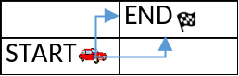

In this case, the town is small and we want to know the number of options to move from the coordinates corresponding to START to the coordinates corresponding to END, taking into account the restrictions. The result is obviously 2, since we first go right and then up or we can first go up and then right.

Example 2

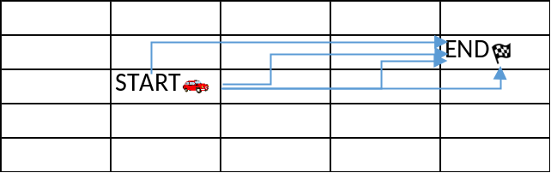

In this case the number of possibilities to get from start to end increases to 4:
- 1) up – right – right - right
- 2) right – up – right - right
- 3) right – right – up - right
- 4) right – right – right - up

Example 3

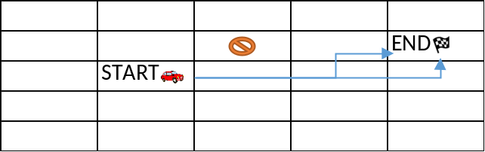

Now we have a barrier that prevents us to go through the coordinate (1,2). So, we have 2 possibilities to reach END.

Example 4

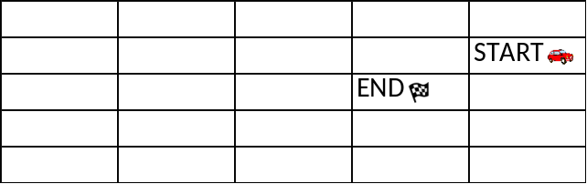

In this case, the result will be -1, indicating that it is not possible to move from a position from the northeast to the southwest. This can be seen as a simplification of the algorithm, which could be extended to allow movements to the south (down) and west (left).

This idea, or variations of it, can be applied to different domains, such as video games or robotics, where it might be interesting to know how many direct paths there are from one point to another.

DEADLINE AND WORK TO BE DONE
You are asked to design and implement an algorithm using dynamic programming to solve this problem optimally.

You should create an Eclipse Project with the name: lab05_DynamicProg<UO> with all the needed files inside.

- Implement in Java such an algorithm to calculate the end result of how many ways we have to go from the start point to the end point in the town.
- You will have 9 test files:
  - case1.txt – Expected result: 2 options
  - case2.txt – Expected result: 252 options
  - case3.txt – Expected result: 0 options
  - case4.txt – Expected result: 6406484391866534976 options
  - case5.txt – Expected result: 4 options
  - case6.txt – Expected result: 2 options
  - case7.txt – Expected result: -1 (not valid input)
  - case8.txt – Expected result: -1 (not valid input)
  - case9.txt – Expected result: -1 (not valid input)
- What is the complexity of the designed algorithm? Do you think you could change the design to improve the complexity?

Regarding the structure of the text files and taking as an example case6.txt, its content is as follows:
5,5
1,2
2,1;1,4

Representing the following:
- First line: size of the city
  - The first 5 would be the width of the city (number of streets in a horizontal direction)
  - The second 5 would be the height of the city (number of streets in the vertical direction)
- Second line: coordinates of the different obstacles in the streets of the city
  - In the coordinate x=1 and y=2 there is a barrier (there could be more, separated by semicolons). If there were no obstacles, this line would be empty.
- Third line: initial and target places
  - The path begins at the coordinate x=2 and y=1 and must end in the coordinate x=1 and y=4

Test the algorithm implemented to check, which effectively provides the right solution, at least for the 9 examples cited above (case1.txt to case9.txt). Those tests are included in the RoadsInCityTest.java class, in which Junit test cases are provided. You only should modify the path for the provided text files (case1.txt to case9.txt) and build a program to make tests run successfully. That is usually called Test-Driven Development and is a best practice for software development you should take into account from now on.

The program will display the initial data loaded from the files (for example, for case2.txt):

Starting position: (6, 0)
Target position: (0, 6)
Representation of the map at the beginning:
0 0 0 0 0 -1 END
0 0 0 0 0 0 0
0 0 0 0 0 0 0
0 0 0 0 0 0 0
0 0 0 0 0 0 0
-1 0 0 0 0 0 0
START 0 0 0 0 0 0
… and the final results for each of the test cases, including the final status of the table and the number of possible paths from the source to the destination.

You should deliver:
- The source files for the classes, which have been programmed within the Eclipse project.
- A document (.docx or .pdf) with a brief explanation of the algorithm used and its complexity. The document should also include the tables created with dynamic programming for the 9 test cases (except for the case 4, since that would be too big).
A task will be enabled in the virtual campus to upload the exercise. The deadline is 1 week and 1 day after the session ends.

The value -1 means a barrier in the way

